The Pillow Project

The Pillow Project was a UI design initiative where our team aimed to transform an everyday object into a smart device and create an intuitive user interface for it. After several rounds of discussions, we decided on a pillow as our focus. Our goal was to integrate smart technology seamlessly into the pillow, enhancing user comfort and functionality.

For this project, we conducted research by interviewing several individuals to understand their needs and preferences regarding pillows. Our goal was to gather insights on what features and qualities are most important to them, ensuring our smart pillow design truly aligns with user desires.

Our team analyzed the affordance of a pillow, highlighting its primary purpose as a support for resting, whether for lying down or propping up the body to enhance comfort. Pillows are designed to be soft to the touch, with varying degrees of firmness to cater to different user preferences.

* What health-oriented metrics would you like to track?
* Do you use any other devices that are involved in your sleep?
* What helps you sleep better?
* What aspects of your sleep would you like to have more control over?
* What is most important to you in a pillow?

These questions, or variations of them, were used in the interviews.

# <INTERVIEWS>

### Andrew Pipo -

Interviewed Significant Other

1. Track REM Sleep
2. Airpods
3. Comfort and white noise
4. Waking up
5. Soft but keeping shape

Interviewed Friend

1. Track oxygen/airflow (breathing or metric that could result in determining cause of snoring)
2. Airpods
3. Noise
4. Not waking up in the middle of the night
5. Comfortable

### Casey Jackson -

**General Sleep Habits:**

1. How many hours of sleep do you typically get per night?

**A: 6.5**

1. Do you often experience discomfort when sleeping? If yes, in what way?

**A: Yes. Muscles aching. Arthritis. Lower back and neck**

**Current Pillow Experience:**

1. What do you like most about your current pillow?

**A: Contoured to keep my neck straighter. Memory foam.**

1. Is there anything you dislike about your current pillow?

**A: Sometimes not as comfortable as needed.**

1. Do you have specific preferences for pillow firmness, height, or material?

**A: Don’t like high pillows or firm pillows. Memory foam is best because you can sink into them.**

**Pain Points & Solutions:**

1. Do you ever wake up with neck pain, headaches, or stiffness?

**A: Yes stiffness and neck pain**

1. If you could change one thing about your pillow to improve your sleep, what would it be?

**A: Make it contour around the neck**

1. Have you ever used or considered using sleep-tracking devices? Why or why not?

**A: I don’t because it was purely informational and wasn’t helpful**

**Desired Features:**

1. Would you be interested in a pillow that tracks your sleep quality (e.g., sleep duration, movement, etc.)?

**A: Informational things aren’t useful because they don’t help with sleep**

1. How important is temperature regulation in your sleep environment? Would a pillow that adjusts its temperature appeal to you?

**A: Probably not of interest.**

1. Would you find value in a pillow that can gently wake you up by vibrating or adjusting its firmness based on your sleep cycle?

**A: Probably not of interest.**

**Ergonomics and Comfort:**

1. Would you prefer a pillow that adjusts its shape or firmness automatically based on your sleeping position?

**A: Yes. Currently turning on side makes things by a challenge**

1. How do you feel about a pillow that offers customizable firmness settings (e.g., adjustable air chambers or foam layers)?

**A: Yes that is good**

1. Would you use a pillow that gives real-time feedback on your posture and suggests adjustments?

**A: Would be willing to try it. Wouldn’t know until I try it**

### Kate Plas-

1. What would you like to health oriented metrics would you like to track
   1. “If I continue on this sleep habit pattern, what neurological diseases am I likely to get”
   2. “Sleep quality, time”
2. Do you use other tools to track your sleep
   1. “no”
   2. “Not anymore”
3. What helps you sleep better?
   1. "In a quiet and cool environment”
   2. “Climate controlled. I also sometimes listen to an audiobook or sleep podcast.”
4. What aspects of your sleep would you like to have more control over?
   1. “The noise”
   2. "I want to stop looking at my phone at night so that I can get more sleep, so I’d like to get control of that habit.”
5. What is most important to you in a pillow?
   1. “Its comfort. Maybe it could have flexible firmness”
   2. “Don’t need much from a pillow.”

### Dylan Bok -

User 1:

1.Track amount of actual rested sleep

2.No

3.Not being too hot/comfortable pillow and mattress

4.The ability to feel rested/wake up easily

5.Solid pillow

User 2:

1.Record my sleep state and restlessness

2.I don't use devices to help my sleep

3.I typically try to stay off electronics/screens 15 minutes before bed. Sometimes I read or play Sudoku to focus then rest my brain

4.Climate and sound. I feel I sleep better at colder temperatures, because then I'm not sweating and restless. Some light sound (AC running, rain, wind) usually soothes me.

5.Elevation because a higher pillow helps my breathing. Also having a cool pillow because I can't sleep in high temperatures.

<INTERVIEW RESULTS>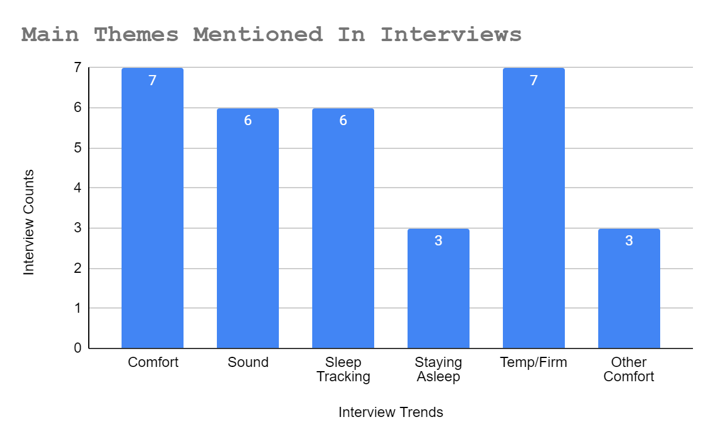

Based on these interviews, we identified some common trends and use cases. Many users rely on sound to aid their sleep, and value the comfort, firmness, and coolness of their pillow. Additionally, there is interest in tracking various aspects of sleep. These insights will guide our development, ensuring our smart pillow meets the key needs and preferences of our users.

Based on the interview results and our group members' personal preferences, we identified several key features we wanted to implement: alarms, white noise, temperature control, pillow firmness, and health tracking. From these initial ideas, we expanded and categorized them into several key areas: Sleep/Health, Alarm, Comfort, Personalization, and Settings. With these categories in mind, we set out to develop some initial design drafts.

# <DESIGN SKETCHES>

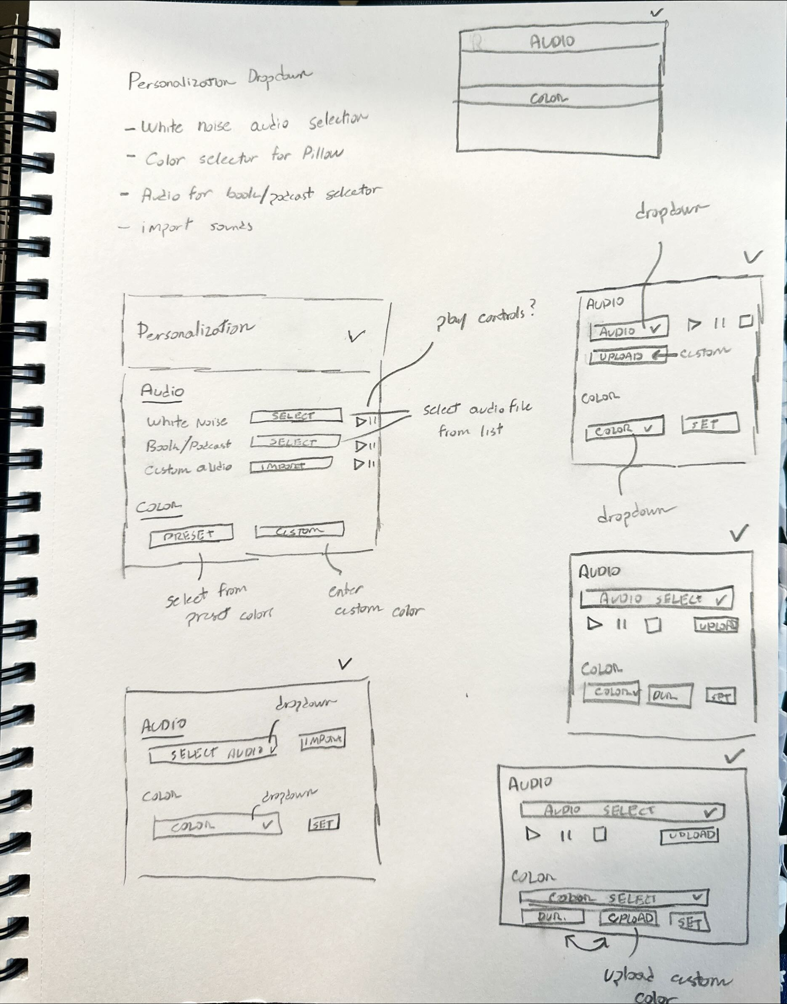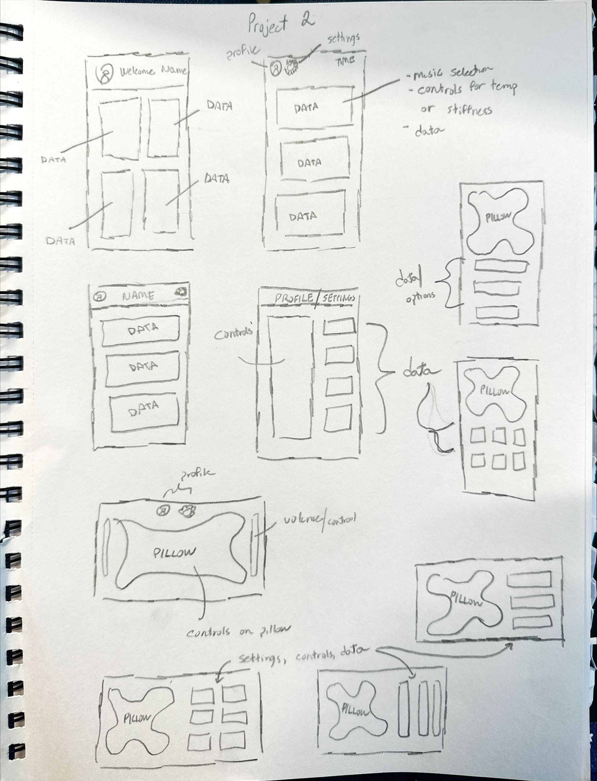

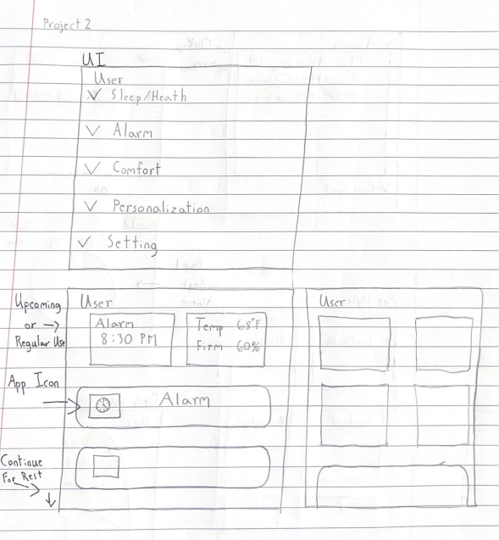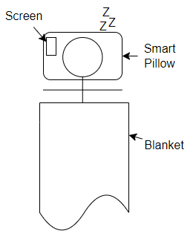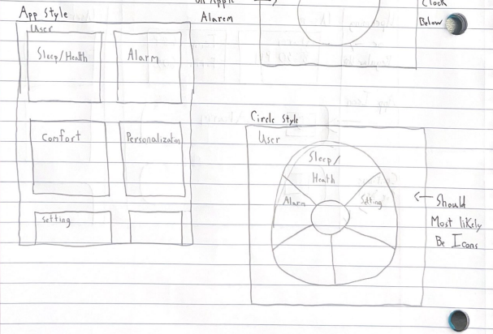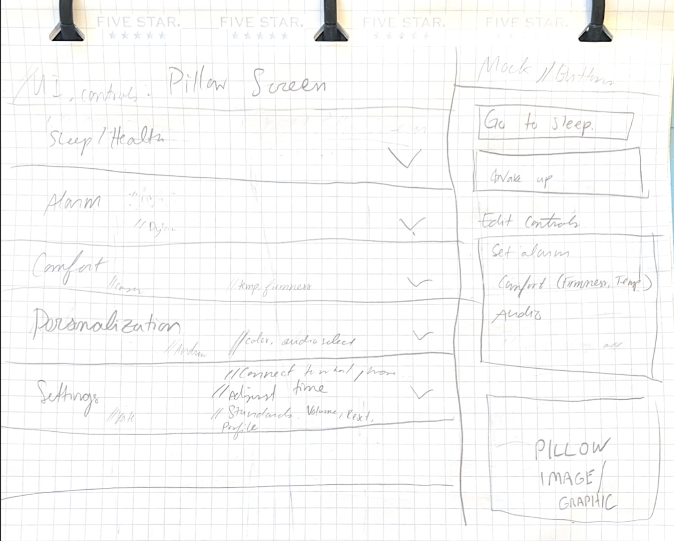

From these design sketches, we decided to use a dropdown system as our initial framework. Each team member then took responsibility for a different section of the dropdowns, ensuring that all aspects were thoroughly covered. This collaborative approach allowed us to efficiently refine and enhance each feature of our smart pillow interface.

# <User Sketch Feedback>

From the limited user feedback we received on the sketches, it was clear that users found the dropdowns too obtrusive, as they occupied the entire screen. Additionally, one user suggested relocating the comfort options to the top of the interface. Another user expressed a preference for the text to have a more rounded and softer appearance, enhancing the overall visual appeal and readability.

# <Final UI Design>

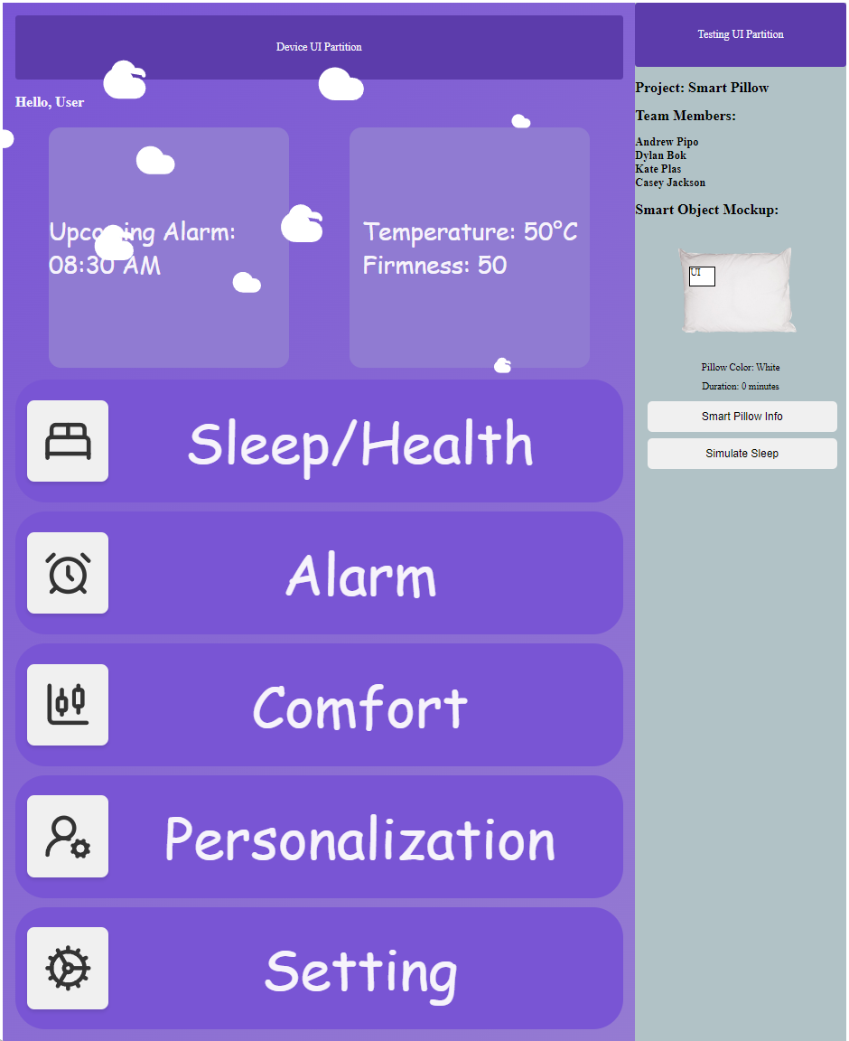

As of 10/22/2024.

# <Sleep/Health>

Kate worked on the Sleep and Health section which displays hours of sleep per day over and the user’s nightly average heart rate the past week. These metrics were developed using the Chart.js JavaScript library. Dummy data was generated and displayed within the two charts to display their metrics. A bar plot was used to display the user’s sleep time trends while a line chart tracks their nightly average heart rate. Additionally, the section calculates weekly averages for both hours slept and nightly heart rate.

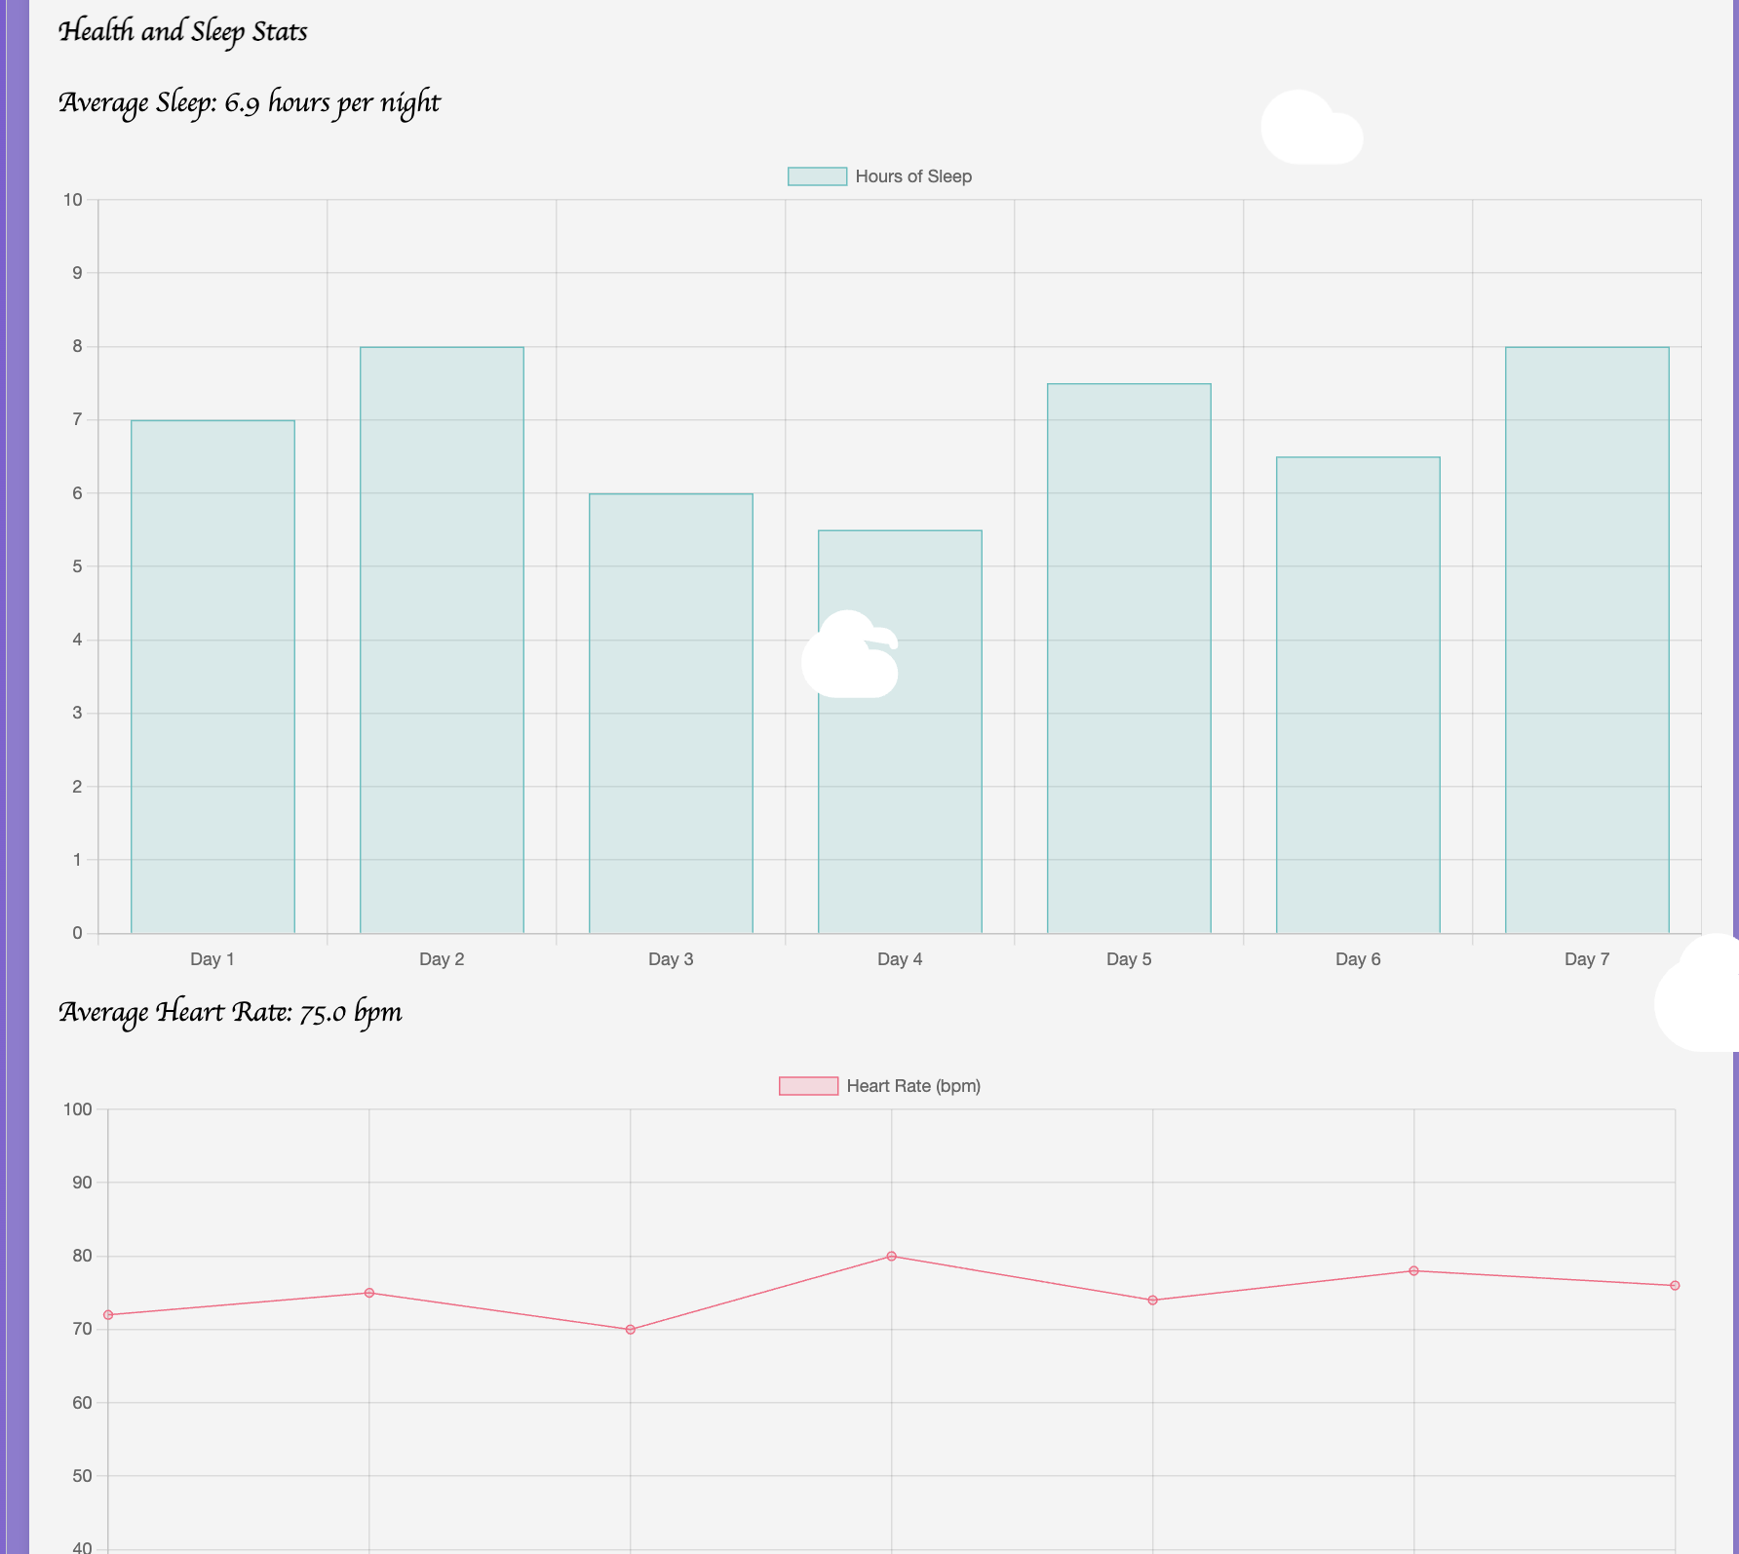

## <Alarm>

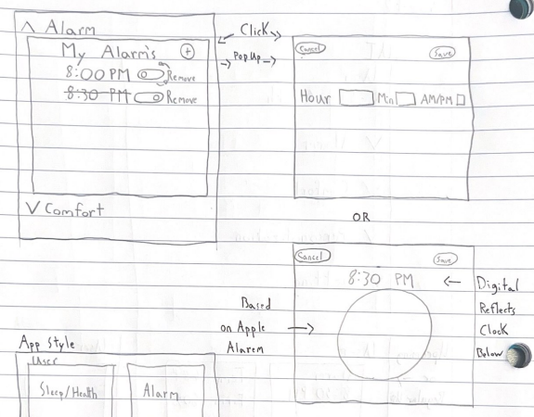

Early Sketch Ideas

Dylan took charge of designing the alarm feature, ensuring it allowed for up to 10 saved alarms simultaneously. The initial sketches for the alarm setting system were inspired by Apple's circular design and dropdown menus. This design, in theory, would enable users to choose a sound, disable alarms without deleting them, and navigate settings intuitively.

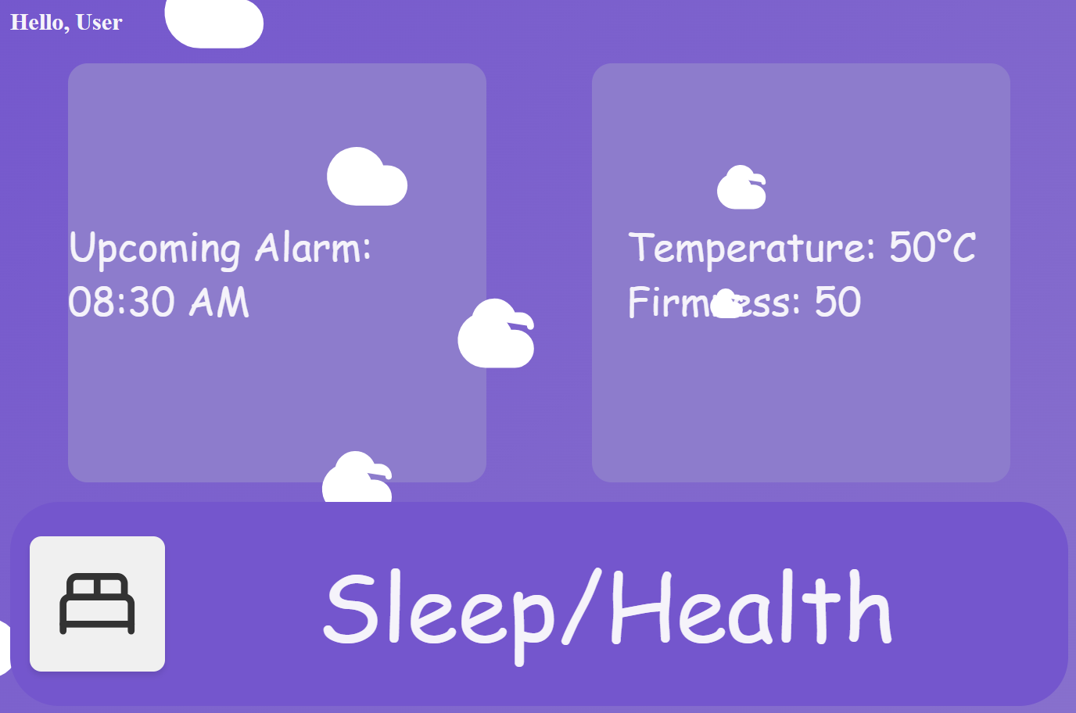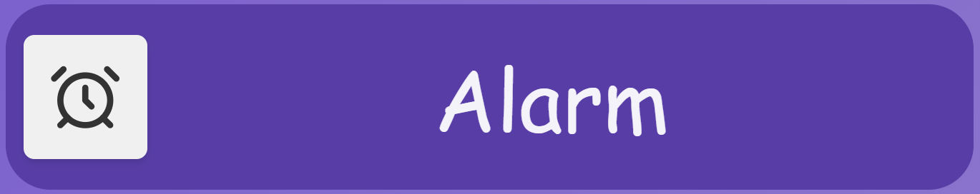

Both choices do the same thing.

To use the alarm, click the box for "Upcoming Alarm" in the top left, or scroll down and select the "Alarm" tab. This opens a section where you can manage and add alarms. Note that there is a cap of 10 alarms, preventing the addition of an 11th alarm. Additionally, the system will not allow setting an alarm for a time that already has an existing alarm.

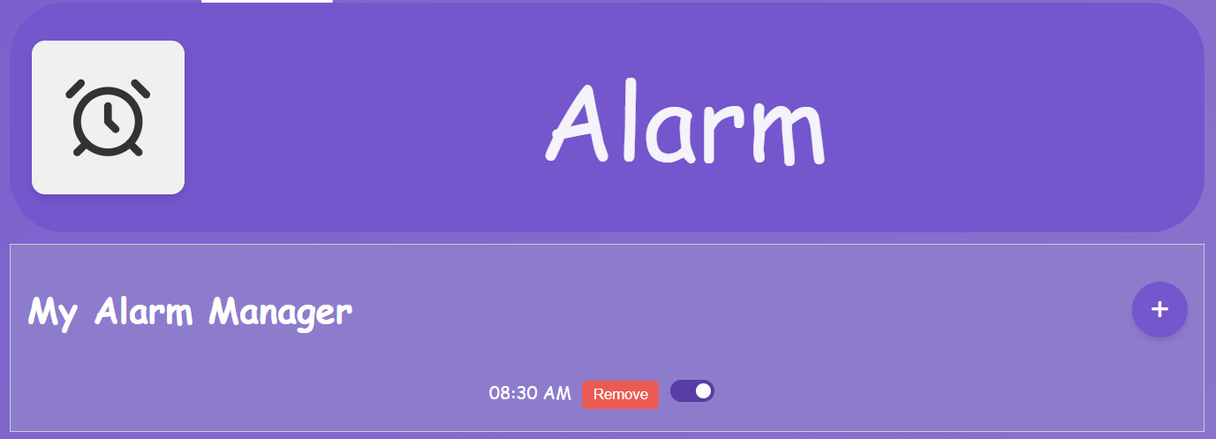

To add a new alarm, click the purple button with the white "+" icon. This opens a menu allowing you to set the alarm time, including the hour, minute, and AM/PM. You can also choose the alarm sound in this menu. Once everything is set, click "Save" to close the menu. Your new alarm will now appear in the list of alarms.

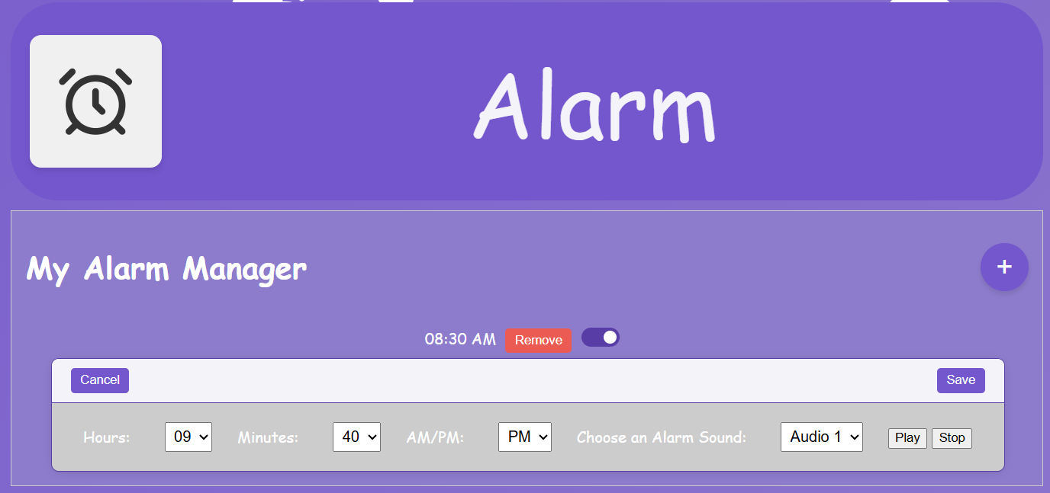Alarm tab open with alarm add menu open.

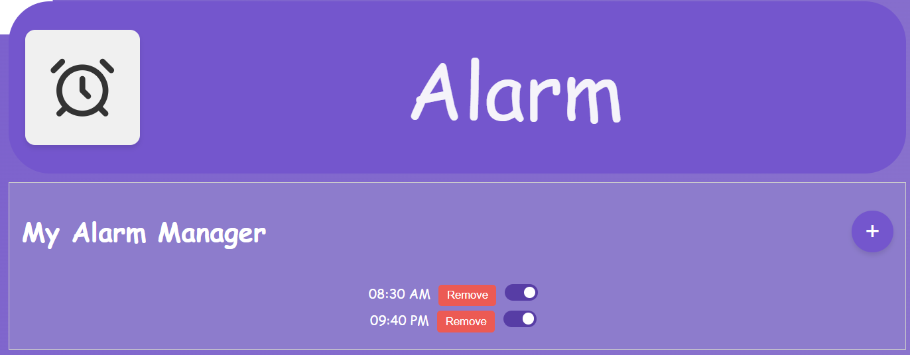Alarms can be easily toggled on or off using the convenient slider.

# <Comfort>

Casey was in charge of design and implementation of the comfort screen, which was for setting the desired temperature and firmness of the pillow. The preliminary sketch below shows the basic idea behind the comfort features.

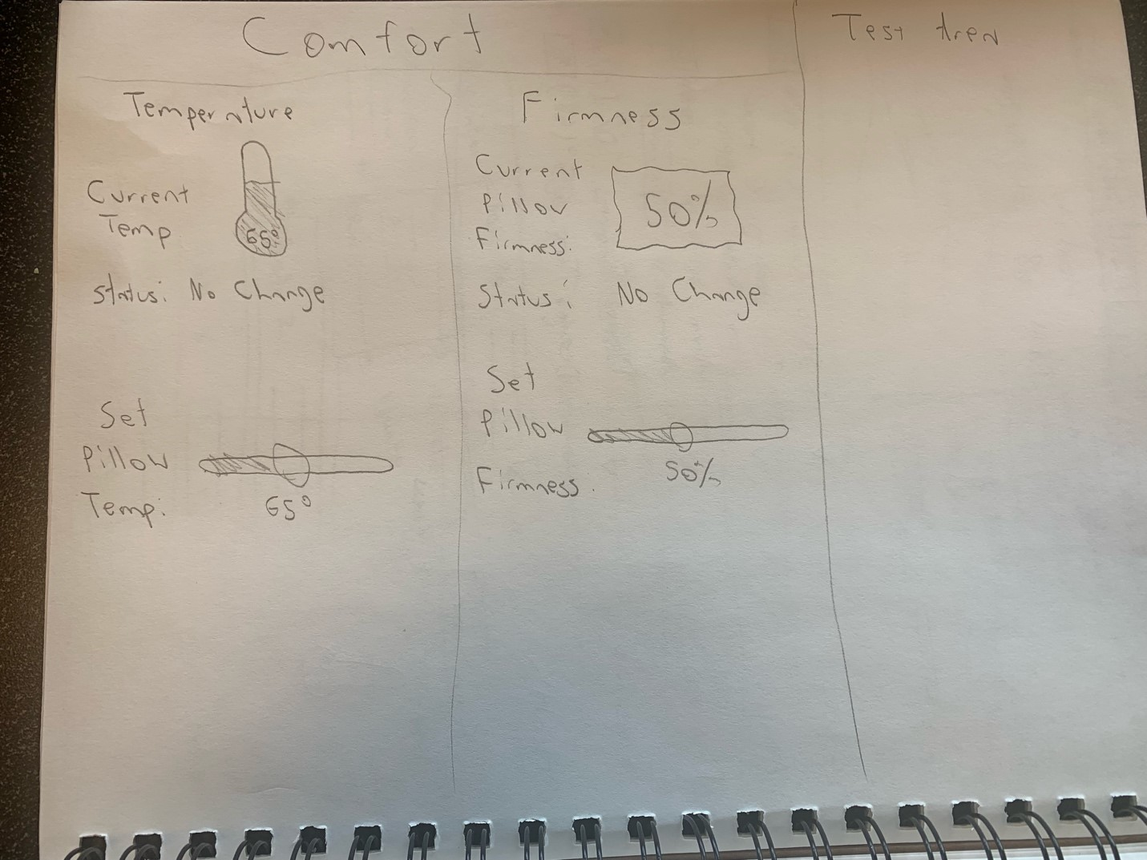

**Comfort Page Initial Design Sketch**

The screenshots below showcase the implementation of the comfort screen in the UI. The implementation ended up being very similar to the initial design. The screen works as follows: The comfort page allows the user to set the desired temperature and firmness of the pillow. To change the temperature, simply move the slider next to where it says "Set Pillow Temperature". After a few seconds the thermometer indicating the actual temperature of the pillow will move to the desired level, simulating the pillow changing temperature. The thermometer changes color depending on the temperature of the pillow. Repeat these steps to set the firmness of the pillow. The percentage shows how firm the pillow currently is, with 100% being the hardest amount. The image below the percentage gives a visual representation of how firm the pillow currently is, going from sponge for softest, all the way to diamond for hardest. The status text also tells the user the current status of the pillow, whether it is heating up, cooling down, hardening, softening, etc. Note a real pillow would likely take longer for the pillow temperature/firmness to reach desired levels.

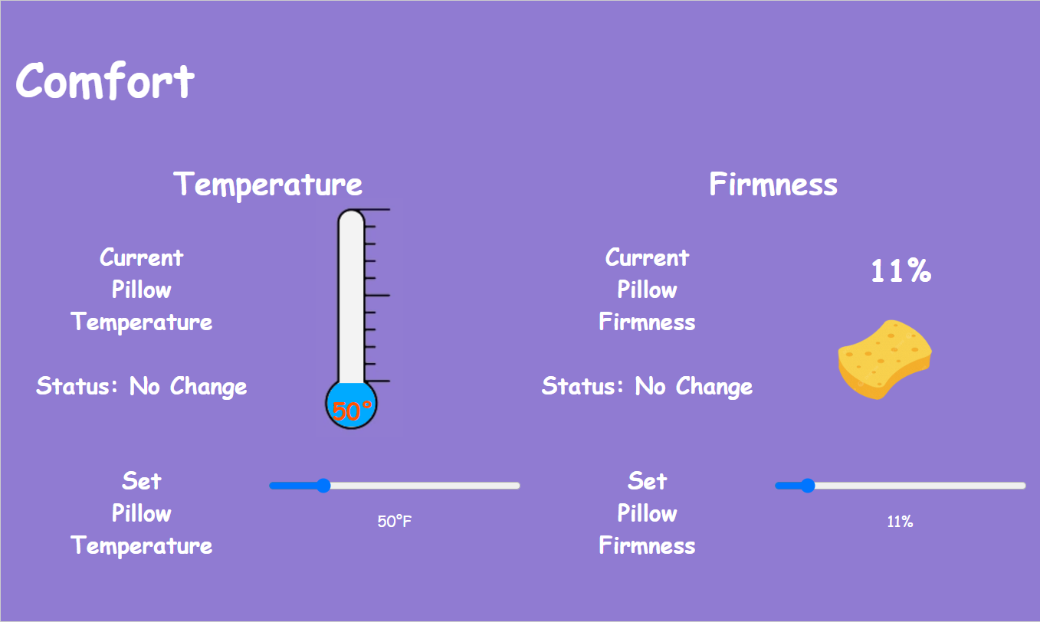**Initial Comfort Page**

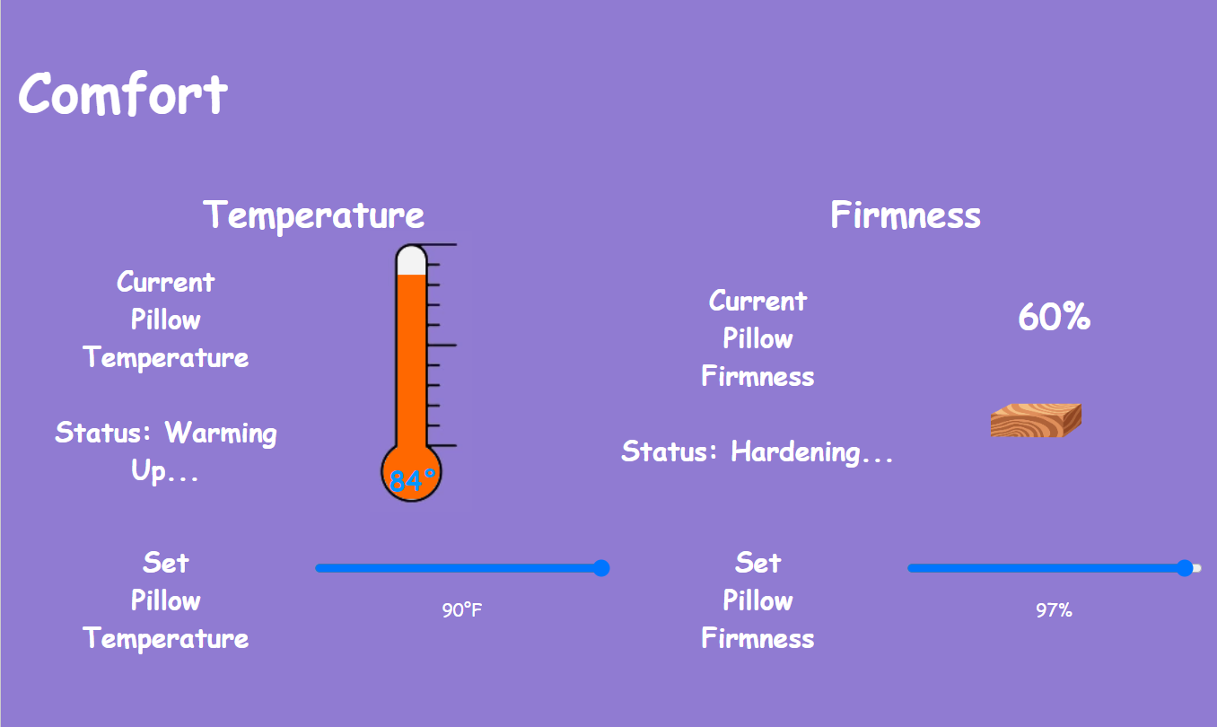**Comfort Page Warming Up/Hardening Pillow**

This specific page was implemented as its own component, with no external libraries, using only the base svelte and JavaScript features. The bars to set the temperature and firmness were implemented using simple range type inputs. The firmness and temperature values were simply set to change gradually after a small delay using a custom wait function implemented with the built-in “SetTimeout” function. Finally, the hardest part to implement was the temperature thermometer. First, I had to find a suitable picture of a thermometer online. Then, I edited the picture so the area inside the thermometer would be transparent. After that, I placed the picture in the desired spot, and then placed a div behind it using custom styling to have it slowly fill up based on the temperature value. Finally, I created a custom temperature color variable to interpolate from blue (cold) to red (hot) based on the temperature and added the color to the div. I used AI to generate a function to interpolate these colors the way I wanted.

# <Personalization>

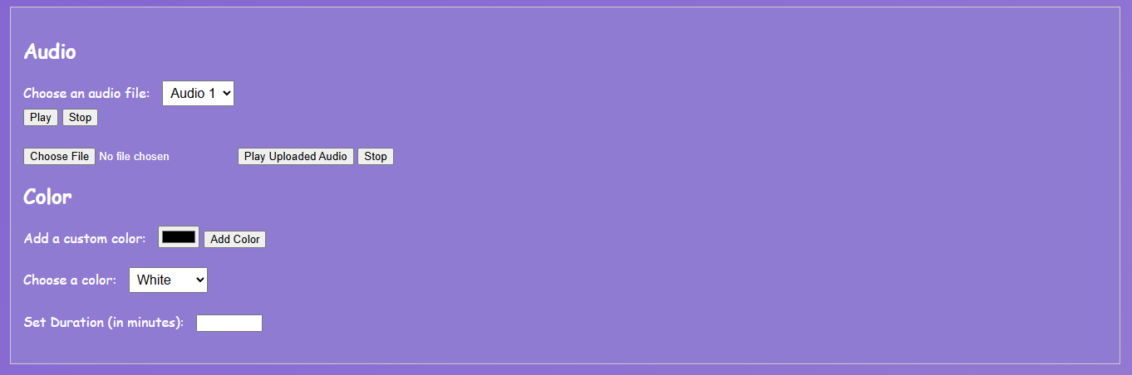

Andrew was responsible for developing the personalization features/functionality of the Smart Pillow. The personalization features include allowing users to play and pause preset audio and allowing users to upload custom audio files, which can be any files with the .mp3 extension. The preset files are already selectable in a dropdown to which a user can select an audio file and click the play or stop buttons to respectively play or stop the selected audio. The custom audio file can be uploaded to the field below alongside the “Play Uploaded Audio” or Stop buttons to play and stop the uploaded audio respectively. The audio functionality would allow users to play any white noise or audiobook as desired.

In addition to the audio functionality, there is also the ability to allow users to change the color of the pillow, to which users can tailor the pillow color to any preset or customized color to help them sleep or to help fit with the theme of a given room. The custom color can be selected from the color picker and added to the color dropdown/list with the “Add color” button. Users can also set the duration, or how long the pillow will be that certain color in the text field below the color picker.

# <Settings>

Kate also worked on the Settings section which allows the user to control device connections, time format, default volume, and profile information. The “Return to Default” button returns these features to the original settings.

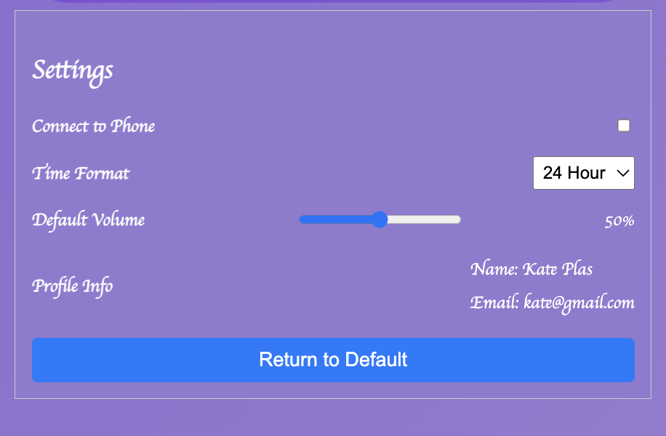

# <Libraries & External Tools>

For this project, we utilized a Svelte framework as our foundation, integrating various libraries to enhance functionality and user experience. Among these libraries, we prominently featured Lucide for its extensive collection of customizable icons, ensuring our design remained both visually appealing and user-friendly.

# <User UI Feedback>

When discussing the UI design with users, the feedback we received emphasized a desire for more color variety, specifically incorporating hues of orange, blue, and green. Additionally, users expressed interest in having the option to change the background to better reflect the time of day—opting for sunny, warm colors during the day and a more subdued, darker color scheme at night. These insights underline the importance of both visual appeal and functional adaptability in our design

# <FUTURE>

Looking ahead, if we had more time to develop this project further, we would aim to incorporate a 3D model with an integrated screen into the pillow. This would allow users to inspect the pillow in a 360-degree simulation, enhancing the interactive experience and providing a more comprehensive view of the smart pillow's features and functionalities. Another thing that would be implemented if we had more time would be to enhance the alarm setting system to closely resemble the design and functionality of Apple's interface.

In addition, with more time, there would have been a modification to the existing audio selection functionality in the personalization section to store all the audio in local storage or a backend database and be able to select between the preset and uploaded audio so that users do not have to reupload the audio every time. Additionally, the preset audio would be renamed, and the custom audio would be able to display their respective names in the dropdown on upload.

Given more time, we would address a set of known issues with the code, some of which can be observed using developer tools in search engines. Additionally, we would fully implement certain code segments that exist but were never polished enough to be usable in the final version, such as the blur effect when inside a menu.

# <THE USE OF AI>

Microsoft Copilot was utilized for the development of the personalization functionality for the backend/JavaScript work. Specifically, the AI was used to help address bugs/issues with setting the audio and ensuring that the audio played and stopped as expected and to address bugs/issues with uploading customized color values to the dropdown and having it reflect on the pillow. AI was also used to assist in developing some more complicated aspects of the comfort page. AI was also employed to check for punctuation and spelling mistakes in both the documentation and the project itself. In certain instances, Microsoft Copilot, ChatGPT, or a combination of both were utilized to add comments to the code.

Example use of A.I.

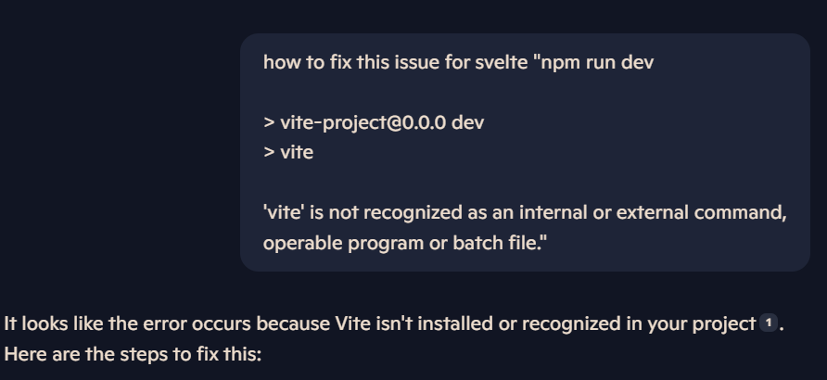Example use of A.I.

# <Video Demo>

[Smart Pillow Demo Video.mp4](https://mailuc-my.sharepoint.com/:v:/g/personal/plaska_mail_uc_edu/EUWkWjL6hJdJpawOu2Uri00Brdtdyy0DfGbgyR7jzES64A?e=x8SCtl&nav=eyJyZWZlcnJhbEluZm8iOnsicmVmZXJyYWxBcHAiOiJTdHJlYW1XZWJBcHAiLCJyZWZlcnJhbFZpZXciOiJTaGFyZURpYWxvZy1MaW5rIiwicmVmZXJyYWxBcHBQbGF0Zm9ybSI6IldlYiIsInJlZmVycmFsTW9kZSI6InZpZXcifX0%3D)

# <GitHub>

<https://github.com/PipoAT/SmartPillow>

# <Live Code>

https://smart-pillow.vercel.app/

# <Credits>

Project Done By:

-Andrew Pipo

-Dylan Bok

-Kate Plas

-Casey Jackson